***Time Series And Forecasting-Final Project***

I pledge that all work I complete for the course will not violate the University of Cincinnati, College of Business, Lindner Academic Integrity Policy on cheating and plagiarism.

Signature: Avinash V Date: 04/25/2018

***Avinash Vashishtha-M12870978***

***Case Study***

The S&P 500, or the Standard & Poor's 500, is an American stock market index based on the market capitalizations of 500 large companies having common stock listed on the NYSE or NASDAQ.

My Index is 51, so the year that I will be analyzing the data is (1950+51) 2001. The data will be analyzed from 1 Jan 2001 to 30 June 2001 and forecasted for the month July 2001.

***Overall Plot of the Data***

proc import datafile="/folders/myfolders/GASUE34_data/table.csv"  
 out=sp500csv  
 dbms=csv  
 replace;  
 getnames=yes;  
run;  
  
proc sgplot data=sp500csv;  
 series x=Date y=Adj_Close;  
 /*symbol1 color=blue interpol=join value=dot height=1;  
 plot Adj_Close*Date/href=0;*/  
run;  
  
Data sp500csv_filter;  
set sp500csv;  
WHERE Date between '01Jan2001'd and '30Jun2001'd;  
run;  
  
proc sgplot data=sp500csv_filter;  
 series x=DATE y= Adj_Close;  
run;

***S&P index for complete time period starting from 1950***

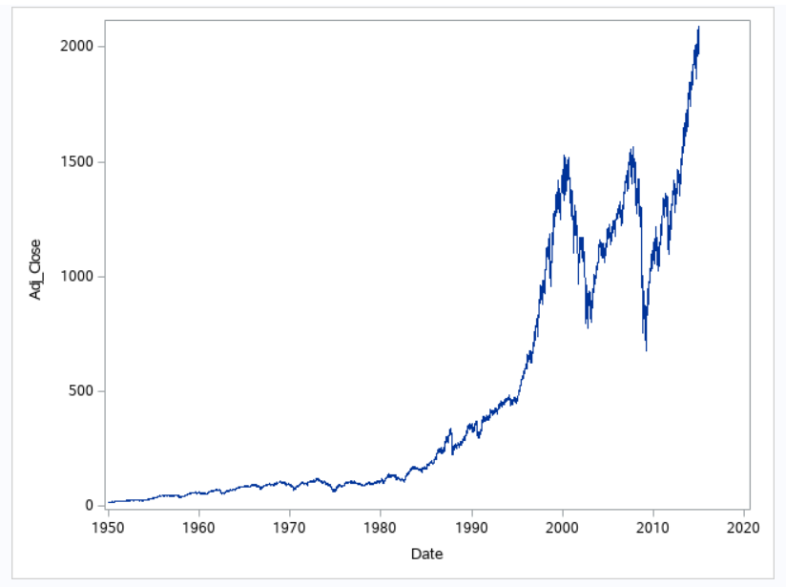

***Filtered for the time period (first 6 months of 2001)***

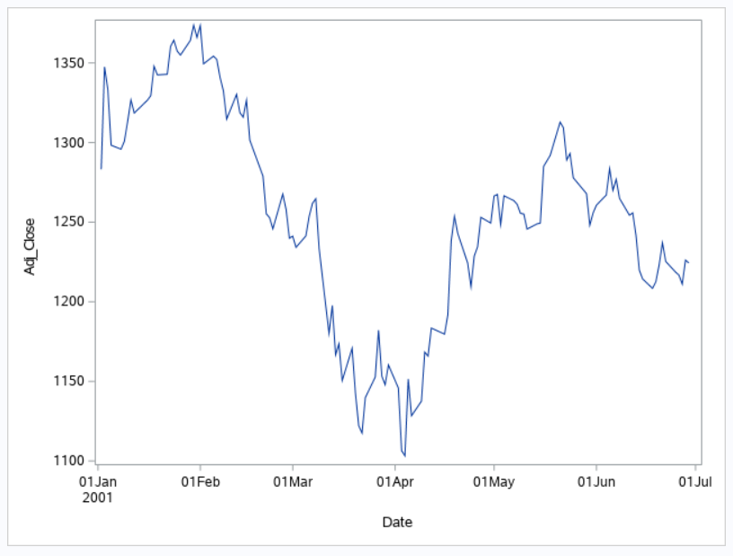

1. **Identification of the model**

We checked for stationarity first using Augmented-Dicker-Fuller-Test and found that the Time series is non-stationary. So, we applied d=1 which passed ADF test. Next, we looked at Plot of ACF/PACF and checked various criteria (Minimum Information Criterion,SCAN, ESACF) to conclude MA(13) model with q=(13). **So,the final model is ARIMA(0,1,13)**

PROC ARIMA data=sp500csv_filter;

IDENTIFY VAR=Adj_Close stationarity=(adf);

RUN;

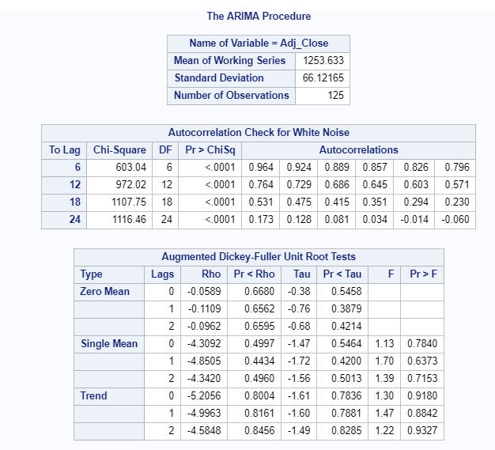

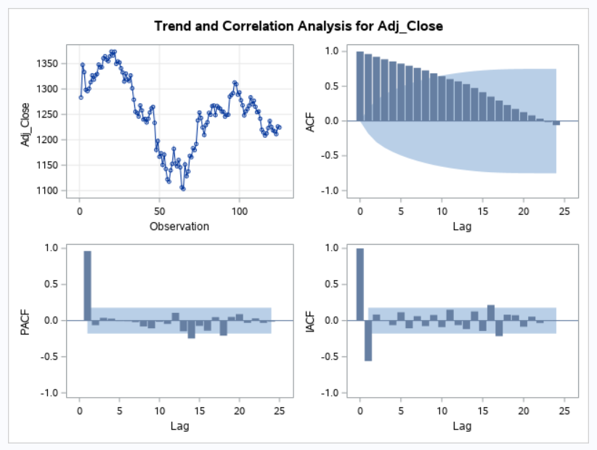

**After taking difference at lag=1, we found that the time series has become stationary**

PROC ARIMA data=sp500csv_filter;

IDENTIFY VAR=Adj_Close(1) stationarity=(adf);

RUN;

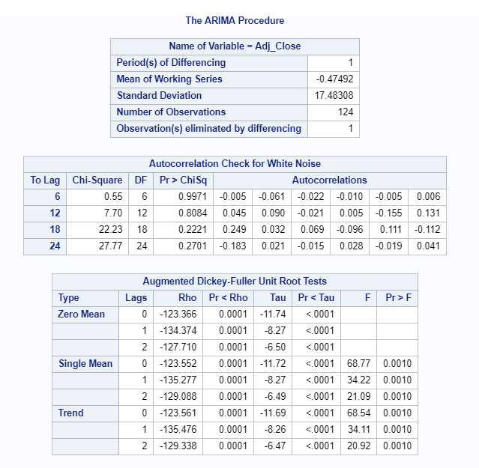

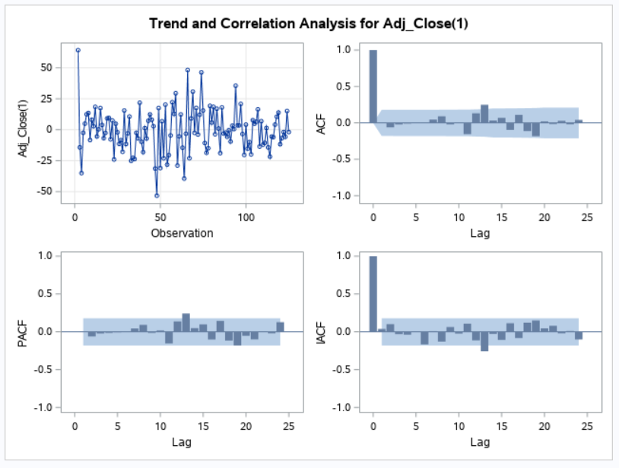

After taking lag=1 and found that although MIMIC, SCAN and ESACF are suggesting ARMA(0,0) which is white noise but we see that ACF plot is non-zero at lag 13, so we decided to go ahead with MA(13).

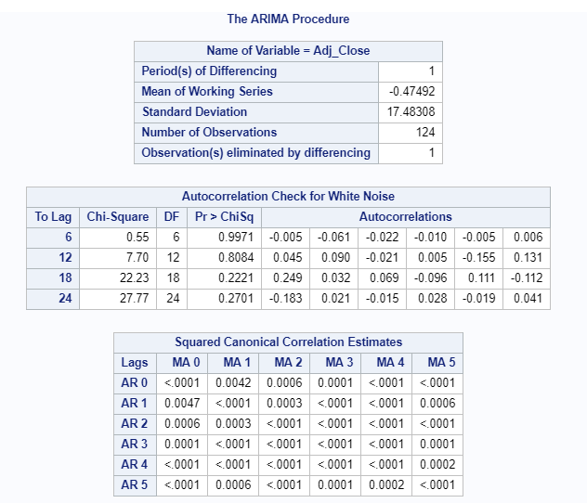

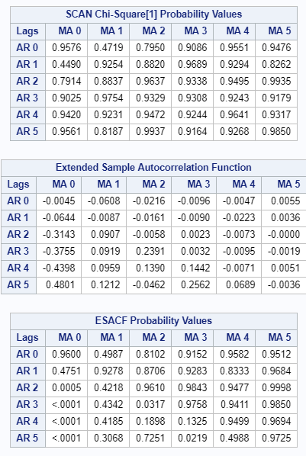

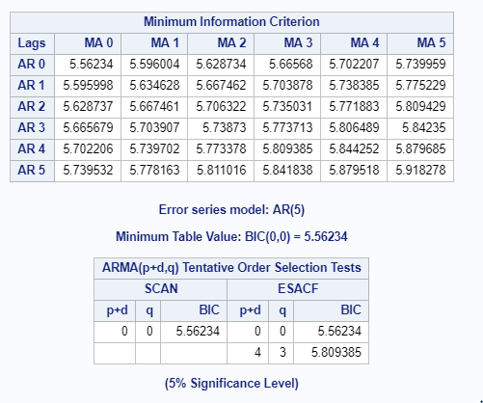



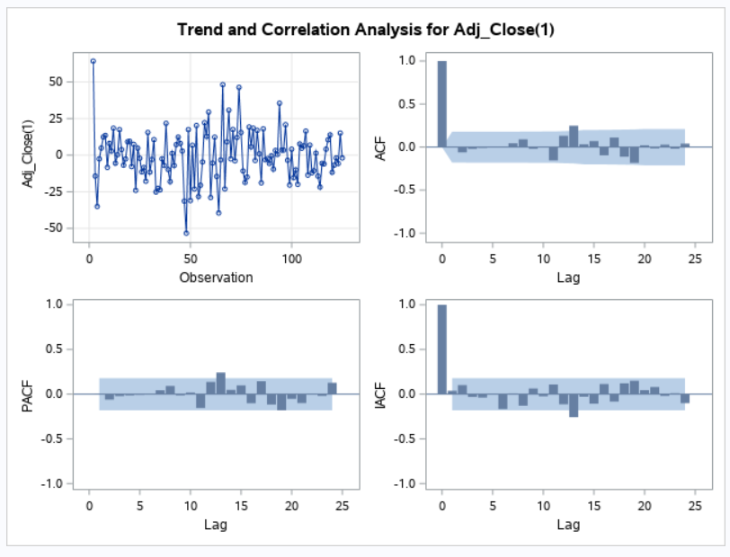



Even though the residual of the fitted model passes bartlett’s test and suggests that the residual is a white noise, we observe that the ACF is non-zero at lag=13. To correct it we decide to apply MA(13) model . But later found that other smaller order terms (<13) are insignificant , so we decided to keep q=(13) with only coefficient at lag individual ACF value at lag=13 is non-zero.

PROC ARIMA data=sp500csv_filter;  
IDENTIFY VAR=Adj_Close(1);  
estimate q=(13);  
RUN;

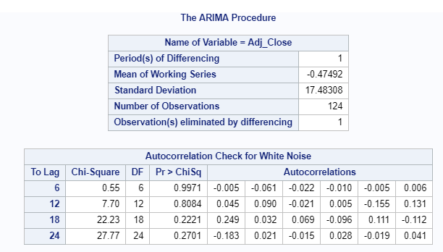

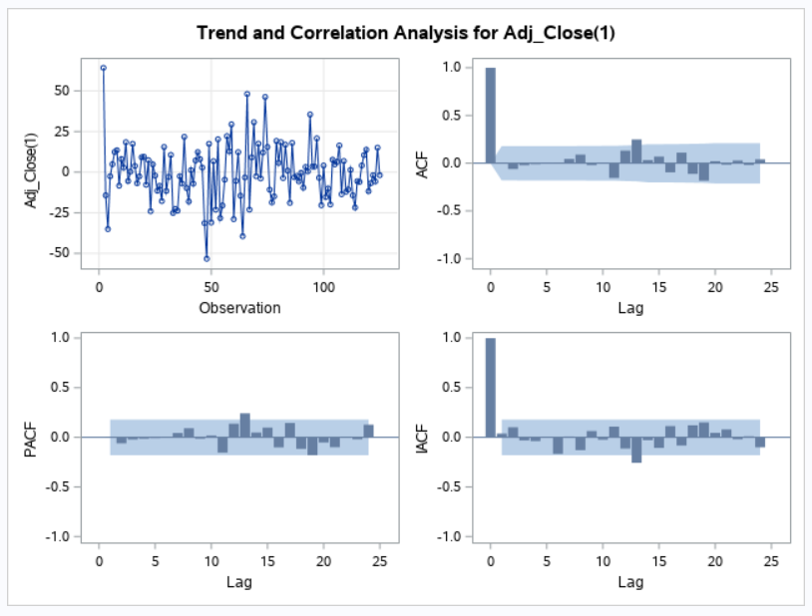

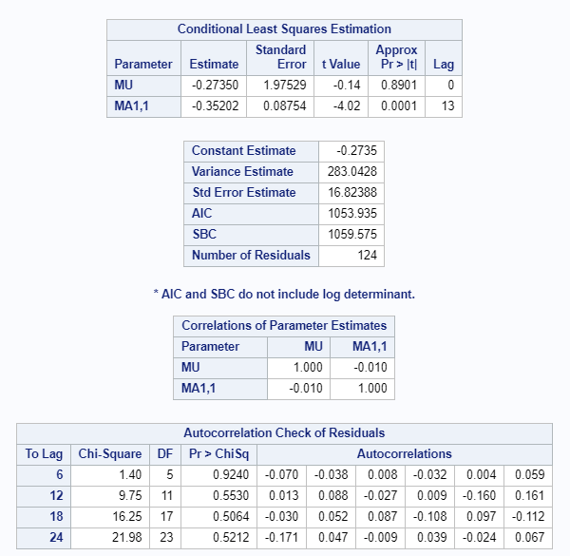

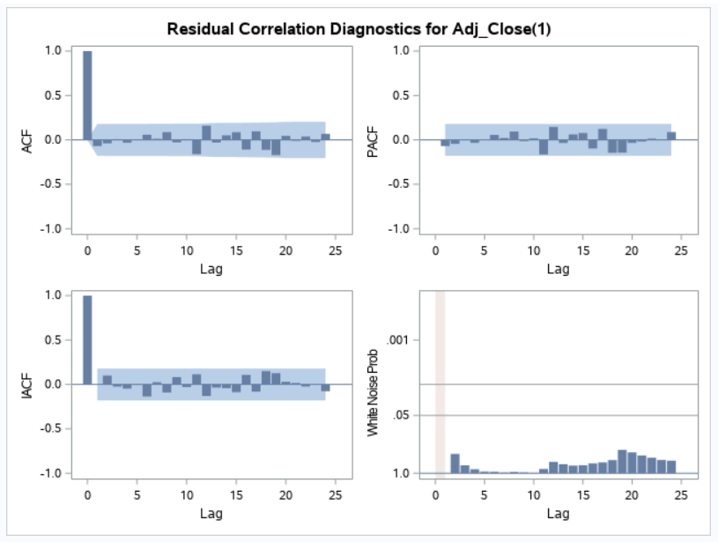

Final Model ARMA(0,1,13) | (1-B)*Zt=(1+0.3526*B(13))*at

* No constant model was run in next step as the p value of mean is insignificant

1. Estimation of the model parameters

**Since the model estimates were coming insignificant for all terms less than lag 13, we decided to keep q=(13) and also we kept noconstant model as the model estimate for mean came out insignificant(As shown above). Model estimates of final model are coming significant**

PROC ARIMA data=sp500csv_filter;

IDENTIFY VAR=Adj_Close(1);

estimate q=(13) noconstant;

RUN;

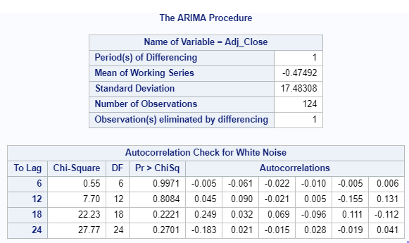

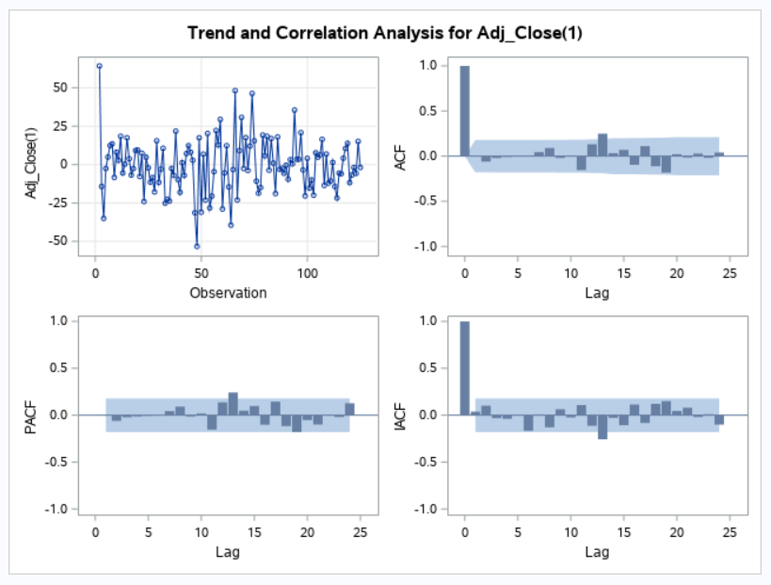

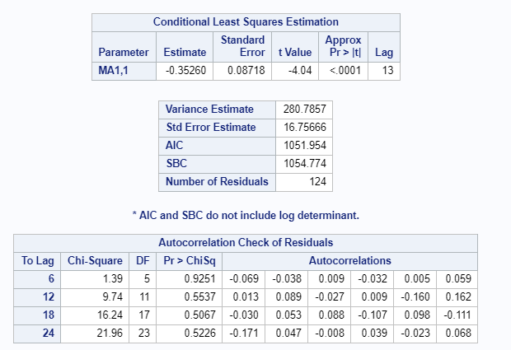

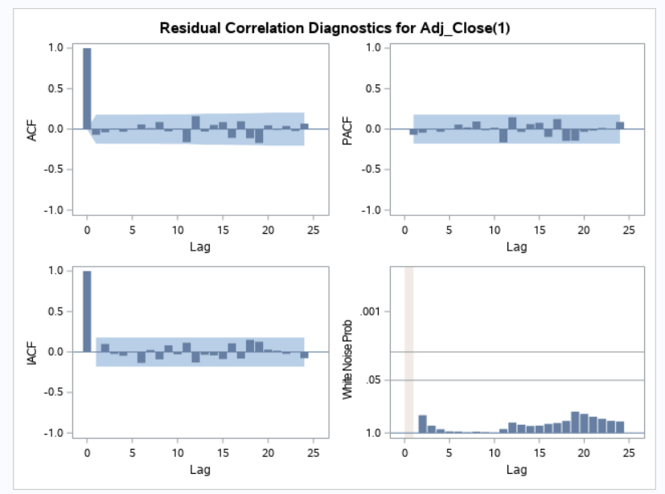

Final Model ARMA(0,1,13) | (1-B)*Zt=(1+0.3526*B(13))*at

1. Diagnostic checking including any statistics

**Residual plots suggest that the residuals are normally distributed and ACF and PACF are zero for all k>1 which suggest that residual is like white noise which follows normal distribution, zero mean and some variance**

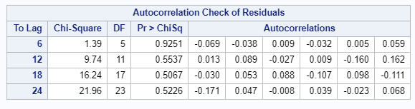

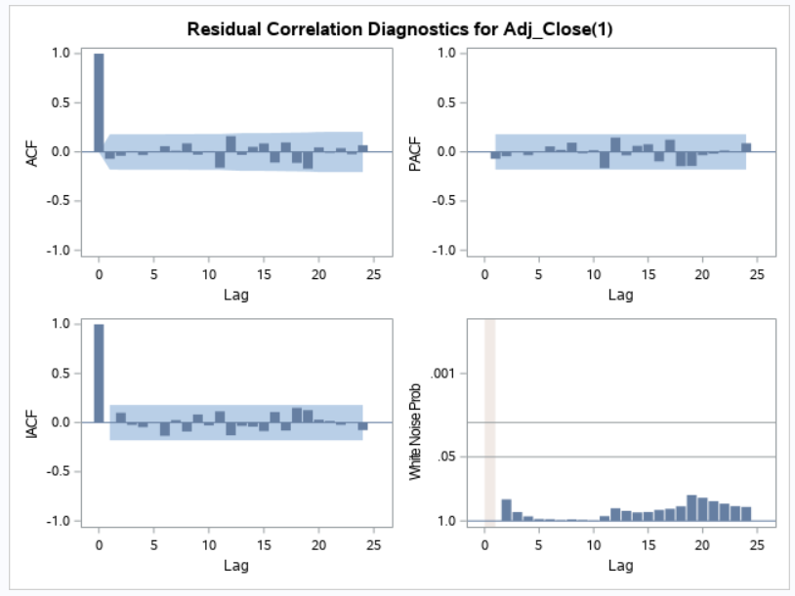

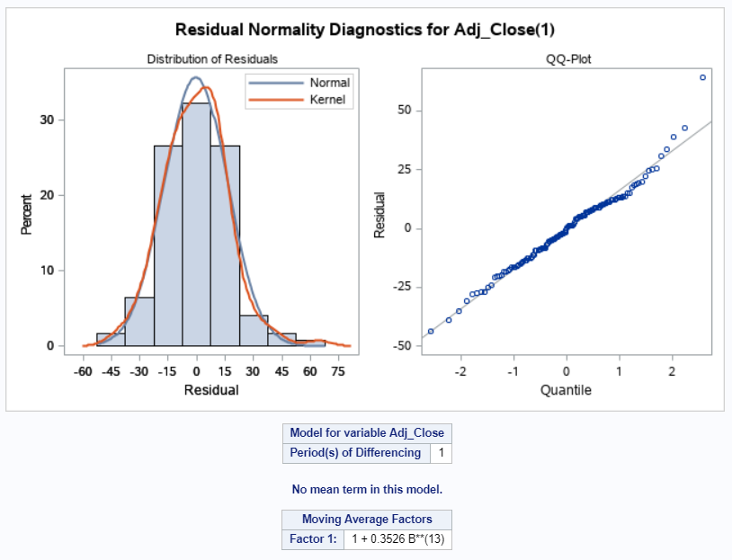

1. Forecasts for the period in question

***Since we have data at daily level and we are forecasting for July month. Around 31 values should be forecasted using the model created above. Results of which are given below-***

* We can forecast for fewer days also as the forecast is not for all days. Stock market is closed on weekends and other holidays

PROC ARIMA data=sp500csv_filter;   
IDENTIFY VAR=Adj_Close(1) minic scan esacf;   
ESTIMATE q=(13) plot noconstant;  
FORECAST lead=31;  
RUN;

| **Forecasts for variable Adj_Close** | | | | |
| --- | --- | --- | --- | --- |
| **Obs** | **Forecast** | **Std Error** | **95% Confidence Limits** | |
| **126** | 1218.0456 | 16.7567 | 1185.2031 | 1250.8880 |
| **127** | 1211.9806 | 23.6975 | 1165.5343 | 1258.4268 |
| **128** | 1211.1685 | 29.0234 | 1154.2837 | 1268.0533 |
| **129** | 1211.6064 | 33.5133 | 1145.9215 | 1277.2913 |
| **130** | 1211.9431 | 37.4690 | 1138.5051 | 1285.3810 |
| **131** | 1215.1215 | 41.0453 | 1134.6743 | 1295.5688 |
| **132** | 1219.0891 | 44.3340 | 1132.1961 | 1305.9820 |
| **133** | 1214.2743 | 47.3950 | 1121.3818 | 1307.1668 |
| **134** | 1213.9712 | 50.2700 | 1115.4439 | 1312.4986 |
| **135** | 1212.3031 | 52.9892 | 1108.4462 | 1316.1601 |
| **136** | 1212.7632 | 55.5756 | 1103.8371 | 1321.6892 |
| **137** | 1219.4832 | 58.0468 | 1105.7136 | 1333.2528 |
| **138** | 1217.5948 | 60.4170 | 1099.1796 | 1336.0099 |
| **139** | 1217.5948 | 64.5284 | 1091.1213 | 1344.0682 |
| **140** | 1217.5948 | 68.3932 | 1083.5466 | 1351.6429 |
| **141** | 1217.5948 | 72.0509 | 1076.3776 | 1358.8119 |
| **142** | 1217.5948 | 75.5317 | 1069.5553 | 1365.6342 |
| **143** | 1217.5948 | 78.8590 | 1063.0339 | 1372.1556 |
| **144** | 1217.5948 | 82.0515 | 1056.7768 | 1378.4127 |
| **145** | 1217.5948 | 85.1244 | 1050.7541 | 1384.4354 |
| **146** | 1217.5948 | 88.0901 | 1044.9414 | 1390.2481 |
| **147** | 1217.5948 | 90.9592 | 1039.3181 | 1395.8714 |
| **148** | 1217.5948 | 93.7405 | 1033.8668 | 1401.3227 |
| **149** | 1217.5948 | 96.4416 | 1028.5727 | 1406.6168 |
| **150** | 1217.5948 | 99.0691 | 1023.4229 | 1411.7666 |
| **151** | 1217.5948 | 101.6287 | 1018.4062 | 1416.7833 |
| **152** | 1217.5948 | 104.1254 | 1013.5127 | 1421.6768 |
| **153** | 1217.5948 | 106.5636 | 1008.7339 | 1426.4556 |
| **154** | 1217.5948 | 108.9473 | 1004.0620 | 1431.1275 |
| **155** | 1217.5948 | 111.2799 | 999.4902 | 1435.6993 |
| **156** | 1217.5948 | 113.5646 | 995.0122 | 1440.1773 |

